✅ Day : Basic Input/Output and Operators (2-8-2025)

1.Write a C program to add two integers.

IPO:

Input- Get two input as integers a and b.

Process- Add both the integers using relational operator and assignment operator (+) and(=).

Output- You will get the sum of the two numbers.

CODE:

#include<stdio.h>

int main()

{

int a,b,c;

scanf("%d%d",&a,&b);

c=a+b;

printf("%d",c);

return 0;

}

OUTPUT:

2. Write a program to swap two numbers using a temporary variable.

IPO:

Input- Get two numbers as input as a and b and a third temporary variable c.

Output- Using the third variable C swap the digits.

Process- The digits will be swapped.

CODE:

#include <stdio.h>

int main() {

int a,b,c;

scanf("%d%d",&a,&b);

printf("a=%d,b=%d\n",a,b);

a=b;

b=c;

c=a;

printf(" swapped-a=%d,b=%d\n",a,b);

return 0;

}

3. Write a program to swap two numbers without using a temporary variable.

IPO

Input-Get two inputs from user as a and b.

Process-Swap the two integers using assignment operator.

Output-The integers will be swapped.

CODE:

#include <stdio.h>

int main() {

int a=11,b=2;

scanf("%d%d",&a,&b);

printf("a=%d,b=%d\n",a,b);

a=a+b;

b=a-b;

a=a-b;

printf(" swapped-a=%d,b=%d\n",a,b);

return 0;

}

OUTPUT: 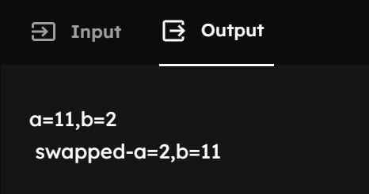

4. Write a program to find the ASCII value of a character.

IPO

Input- Get variable from user like ‘a’

Process- Each alphabet and number has it’s ascii key code value. So print to get the assigned value for your variable.

Output- Ascii key code value for your character will be printed.

CODE:

#include <stdio.h>

int main() {

char ch;

scanf("%c",&ch);

printf("The ASCII value of '%c' is %d.\n", ch, ch);

return 0;

}

OUTPUT:

5. Write a program to calculate the area and perimeter of a rectangle.

IPO:

Input- Get the values from the user for length and breadth.

Process- The formula to calculate the are of rectangle is ARE= LENGTH X BREADTH for perimeter is PERIMETER= 2(LENTGH+BREADTH)

Output- The area and perimeter of rectangle will be printed:

CODE:

#include <stdio.h>

int main() {

float area,perimeter,l,b;

scanf("%f%f",&l,&b);

area=l\*b;

perimeter=2\*(l+b);

printf("area of the rectangle=%f\n area of perimeter=%f",area,perimeter);

return 0;

}

OUTPUT:

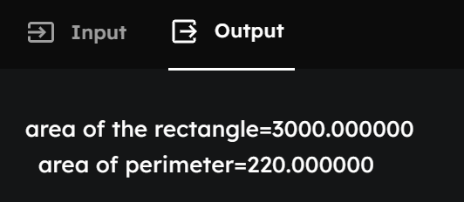

6. Write a program to compute the simple interest.

IPO

Input-The program declares four variables: principal, rate, time, and simple Interest.

Process-The program implements the simple interest formula: SI = (P \* R \* T) / 100.P is the principal amount, R is the annual interest rate (as a percentage),T is the time duration in years.

Output- The calculated simple Interest is then displayed.

CODE:

#include <stdio.h>

int main() {

float principal=1000, rate=5, time=3, Simple Interest;

Simple Interest= (principal \* rate \* time) / 100;

printf("The Simple Interest is: %.f\n", Simple Interest);

return 0;

}

OUTPUT:

7. Write a program to convert temperature from Celsius to Fahrenheit.

IPO

Input- Get a integer to be put in as Celsius

Process- Covert the entered value into Fahrenheit using the formula Fahrenheit=(Celsius\*9/5)+32

Output- As the output Celsius will be converted into Fahrenheit.

CODE:

#include <stdio.h>

int main() {

float celsius=80, fahrenheit=50;

fahrenheit = (celsius \* 9 / 5) + 32;

printf("Temperature in Fahrenheit: %.f\n", fahrenheit);

return 0;

}

OUTPUT:

8. Write a program to find the quotient and remainder of two integers.

IPO:

Input- Get two integers say a and b.

Process- Using arithmetic operators / for quotient and% for remainder and statement remainder=a%b and quotient=a/b we will find the remainder and quotient.

Output- The output for quotient and remainder will be printed.

CODE:

#include <stdio.h>

int main() {

int remainder,quotient,a=5,b=10;

remainder=a/b;

quotient=a%b;

printf("Quotient = %d\n", quotient);

printf("Remainder = %d", remainder);

return 0;

}

OUTPUT:

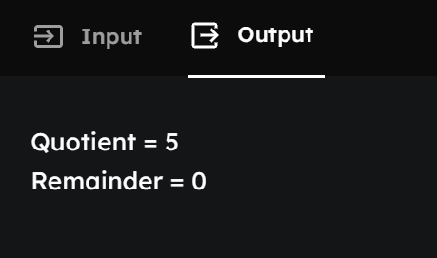

9. Write a program to check whether a number is even or odd.

IPO:

Input- Get two values for variables a and b

Process- Use relational operator and assignment operator = %, if a%2== 0 then it is even else it is odd, we are using else if statement.

Output- if the number is even then it will be printed even if not then it will be printed as odd.

CODE:

#include <stdio.h>

int main() {

int a;

scanf("%d",&a);

if(a%2==0)

printf("%d is an even number.\n", a);

else

printf("%d is an odd number.\n", a);

return 0;

}

OUTPUT:

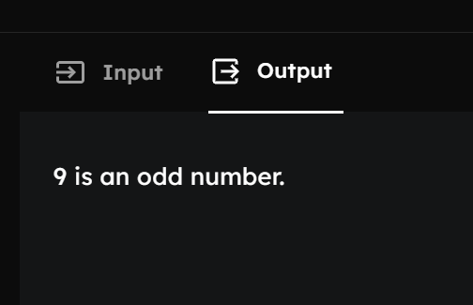

10. Write a program to calculate the square and cube of a number.

IPO:

Input- Get a number as input say a.

Process- for squaring- a x a and to cube a x a x a.

Output- square and cube will be printed.

CODE:

#include <stdio.h>

int main() {

int number,square,cube;

printf("Enter an integer: ");

scanf("%d", &number);

square = number\* number;

cube = number \* number \* number;

printf("The square of %d is: %d\n", number, square);

printf("The cube of %d is: %d\n", number, cube);

return 0;

}

OUTPUT:

